HOW-TO-GUIDE ON HOW TO USE SENSIBEL BUTTON

‘Sensibel is a participatory platform that enables citizens to share their travel stories through the simple act of placing a positive or negative point along their journey. Points can be annotated with text, and images.’

Step One:
Download the Sensibel App!
This is super easy, all you have to do is go onto your smart phone. Either go to the App store or Google Play and search ‘Sensibel‘ and then get downloading!
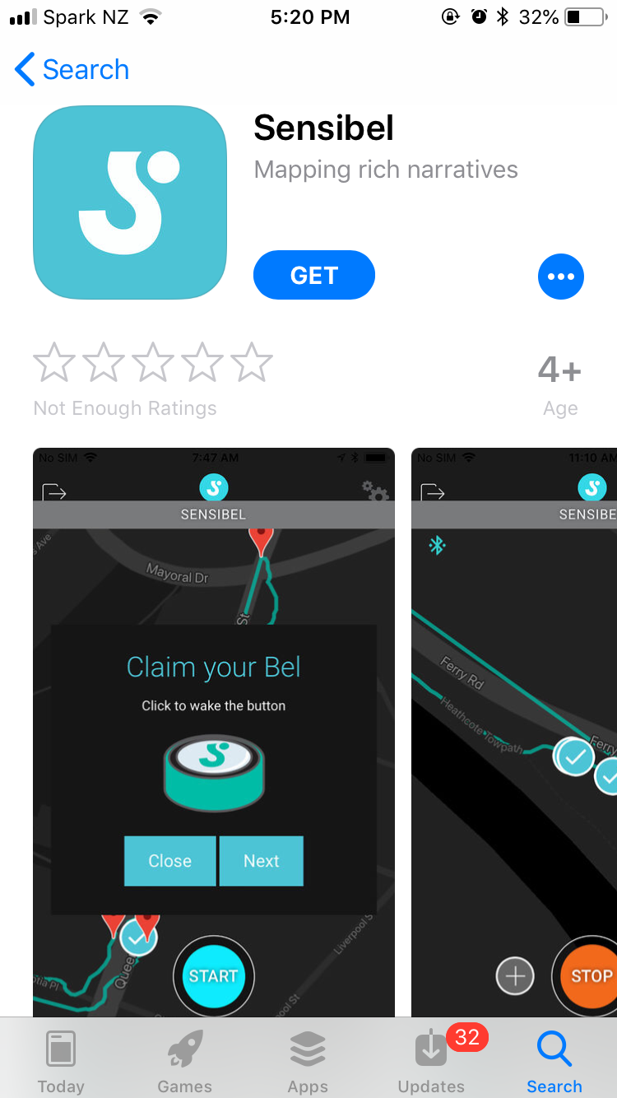
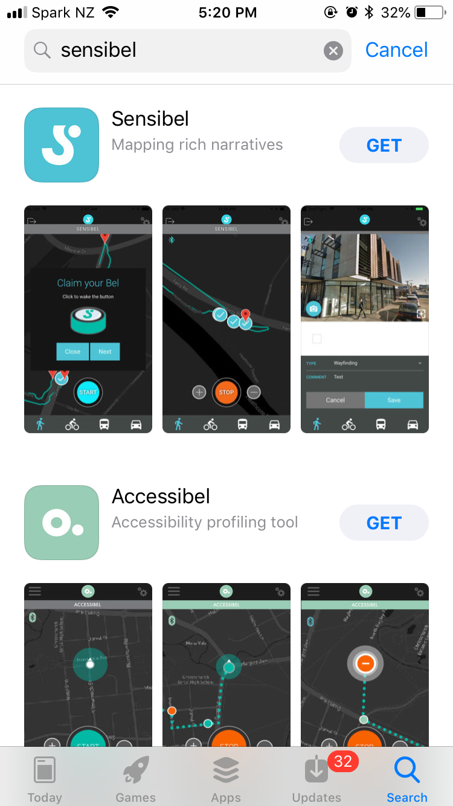

Step Two:
Get your Sensibel button.
This device is an awesome part of Sensibel. This will allow you to easily give your positive and negative feedback while cycling around Christchurch. You give the button a quick push for a positive response and a long push for a negative response… how cool right?

Step Three:
Connect your Bel device to your app using Bluetooth.
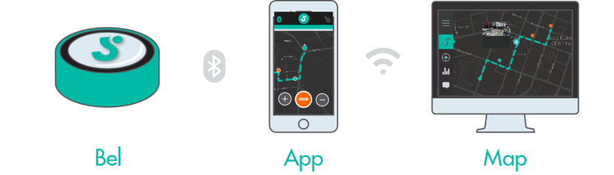
So now that you’ve actually got the button, you need to connect it to your account on the Sensibel app. Don’t worry, it’s easy as 1,2,3!
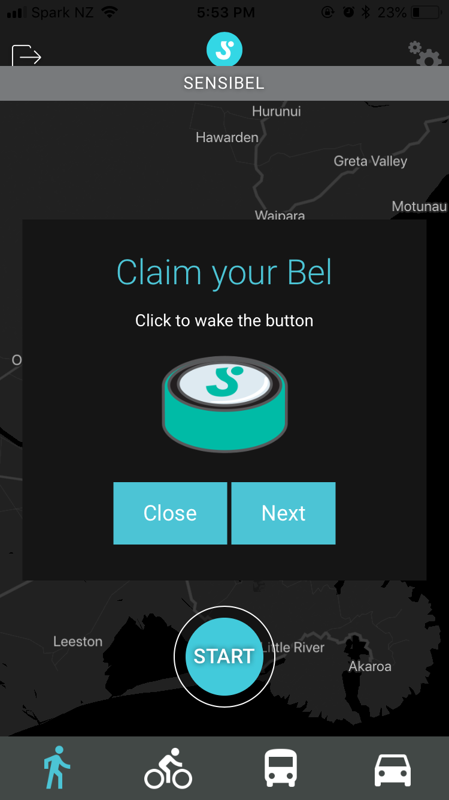
All you need to do is turn on your Bluetooth and a prompt will come as shown in the photo. Then you just click the button on your Bel and you’re set to go.

Step Four:
Get out there and get active!
The whole point of this is to get out there, have your say in the community and get active. So, hop on your bike and show us the best parts of your city and the parts that could be worked on because your voice matters!
Remember on the Bel: Short click for positive and long click for negative.

Step Five:
Give more information on the App.
Whether it’s positive or negative, go onto the Sensibel app and give more information. The Sensibel button is an easy way to give quick feedback while cycling but the app allows you to give detail. You can take photos and comments! It only takes 30 seconds out of your day, so why not!

*You can also map your journey on the app to show the good and the bad, just made sure you turn on your location.

